MAPPING THE VALUE OF COMMERCIAL PV APPLICATIONS IN THE US
ACCOUNTING FOR EXTERNALITIES
Richard Perez & Marek Kmiecik ,
ASRC, The University at Albany 251 Fuller Rd Albany, NY 12203
perez@asrc.cestm.albany.edu
Christy Herig
NREL 1617 Cole Blvd Golden, CO 80401
herigc@tcplink.nrel.gov
Howard Wenger
Astropower Solar Park Newark DE 19716-2000
hwenger@msn.com

ABSTRACT
In previous publications, we reported on the geographical distribution of the economic feasibility of customer-owned commercial PV systems in the US [1,2]. The results showed that several regions in the country were near or above economic breakeven. However, we noted that these results only reflected business as usual assumptions. They did not account for existing or prospective external value elements that could, depending on the application, considerably increase PV’s feasibility threshold. In this paper, we look at the individual and combined impact of the following value elements: (1) Replacement Value, (2) enhanced load management value, (3) emergency value and (4) environmental value. We show that accounting for these elements could significantly increase the size of cost-effective niche markets for customer-owned commercial PV installation.
1. INTRODUCTION
Our interest in customer-owned PV applications [1,2,3] stems from (1) the vast PV deployment potential on roofs and building envelopes [4], and (2) a simple economic reality: demand-side customer-owned PV systems are gauged against high-value retail electricity rates. For residential applications this assumption is only relevant when net-metering legislations are in effect. For the commercial systems considered here, the availability of net metering is less of an issue – unless specific provisions are in effect -- because most commercial buildings have sizable minimum loads; hence large PV systems can be sized so as to never feed-back on the grid. In addition, we have shown [5] that customer-sited PV installations could reduce the demand of certain classes of commercial customers (e.g., office buildings, hospitals) by a substantial fraction of installed PV capacity.
Most of the external value elements considered in this paper are directly relevant to customer-sited PV applications.
2. METHODS
2.1 Economic Feasibility Determination Approach
We previously evaluated PV systems using a straightforward life-cycle economic analysis consisting of comparing the present value of a system to its cost. The present value of a system originates from energy consumption offset and demand reduction, the retail value of energy and demand, plus fiscal and other financial incentives, as applicable locally. In this paper we conserve this approach, but we take external value elements into consideration as well (see Fig. 1).
Economic feasibility is quantified with the Breakeven Turnkey PV system Cost (BTC), corresponding to net a present value of zero with respect to a reference investment – the discount rate. As before [1], we set the after tax return of this reference investment at 9%, that is, well above secure government bonds, but below more volatile stock market returns.
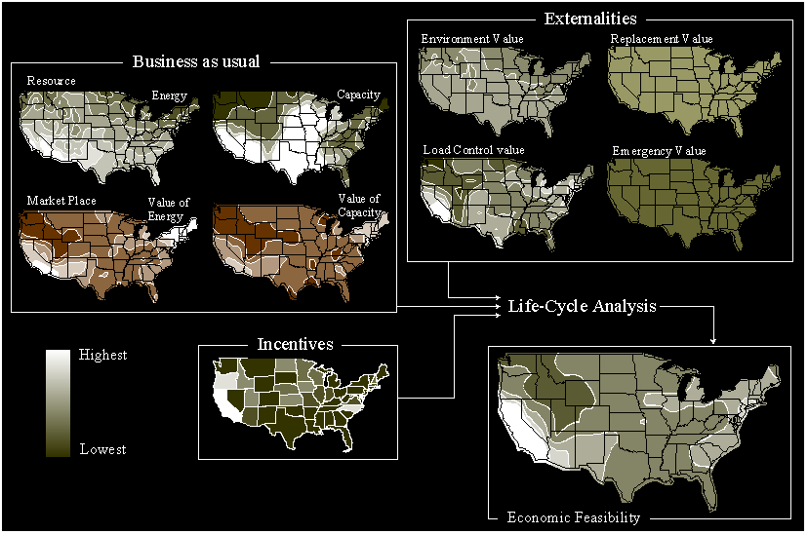
Figure 1: Economic Feasibility Determination Approach
2.2 Inputs and Assumptions
All the financial parameters of the life cycle analysis are identical to those specified in Table 1 of [1]. All variable physical and economical inputs are, with a few exceptions, identical to our past publication:
- Energy Production: Localized PV energy output is simulated from satellite-derived irradiances and ground surface meteorological data [6].
- Demand Reduction: Demand-side localized peak load reduction capacity is assumed to be commensurate with the effective capacity a PV array may provide to the considered regional grid on a yearly basis (see discussion in [1]). Regional PV effective capacities were previously determined [7,8].
- Incentives: For tax incentives, we consider, as before, Federal & State tax credits, low interest loans, accelerated depreciation, deductions, grants and co-payments, but not sales and property tax incentives (see discussion in [1]). We continue to make ample use of the Dsire database as our primary information source [9]. The incentive environment is very similar to our 1998 study, with one major difference in California, where the deregulation negotiations resulted in a substantial buy-down program currently set at 40%.
- Retail Rates: Secondary service retail energy and demand rates corresponding to small-to-medium commercial customers were assembled for 135 major utilities providing a representative coverage of the entire country. We do not account for deregulated choices offered in some of the considered service areas – note however, that this choice would only influence a small fraction of the total rate paid by most customers and have negligible impact on this study.
2.3 PV Array Geometries
Last year, we compared 5 array configurations: 2-axis tracking, fixed at latitude minus 10º, horizontal, vertical south and vertical west. In this paper we focus our attention on two configurations likely to be representative of most building integrated cases: fixed and vertical west. The reasons for this choice are: (1) Fixed and horizontal systems were found to have comparable economic feasibility thresholds [1]. (2) South and west vertical arrays also exhibited comparable economic performance, with a slight edge for the west-facing configuration, particularly in the service area of summer-peaking metropolitan utilities. (3) Tracking configurations are not as well adapted to building-integrated design and cannot capture one of the externalities considered in this paper. We do, however, retain the 2-axis tracking configuration as a reference case.
2.4 Externalities
Replacement Value: Building-integrated PV systems can replace building components that would otherwise be required, such as glazing or roofing. This value element is, of course, project-specific, but it is tangible and could be applicable today in many commercial PV applications. For vertical arrays replacing glazing or cladding, the replacement value may range from $60/m2 for conventional glazing to $200/m2 for stone or metal paneling [10]. We selected a middle ground value of $100/m2 corresponding to Spandrel glass. Assuming a typical conversion efficiency of 6% for PV glazing, the replacement value amounts to $1700 per kW. For roofing, some of the technologies available today bundle insulation and a weather skin with PV, achieving a replacement value of the order of up to $60 /m2 [11]. In addition, roof-mounted PVs, by adding insulation and/or providing shade, can reduce building energy consumption. Simulations have shown [11] that these savings could, depending on the considered situation, amount to up to 25% of the energy produced by the PV array. Here we conservatively selected $40/m2 for replacement value with an energy-saving premium of 15% of PV output.
Enhanced Load Management Value: In an ongoing research project [12], the authors are investigating the possibility of increasing the effective capacity (i.e., the demand-reduction potential) of PV systems through an innovative low-cost / low user-impact load control system that could become part of typical commercial PV installations. The load control approach consists of unobtrusively adjusting HVAC or appliance settings, or adjusting their timing, as a function of load requirements and PV output in order to maximize effective capacity. A prototype controller is currently being tested at the CESTM building in Albany. This particular prototype adjusts end-use indoor temperatures to maximize PV peak shaving capability. Several load control simulations have been performed using real building loads [13]. These investigations show that an unobtrusive action on indoor temperatures (of the order of 2ºC-hour or less for less than ten days in a year) could raise the [already significant] effective capacity of PV by 10-25% for PV systems sized at 10% of a building’s peak load. Pending success of our current development and the incorporation of these simple load control techniques into PV installations, this externality could also be considered as a tangible, albeit project-specific, element. For this paper, we set the controller-induced demand reduction enhancement at 17%.
Emergency Value: Recent power outages caused either by heat waves leading to regional blackouts, or caused by severe weather leading to lasting localized power losses, have caused considerable economic and social disruption and have captured the attention of the press, governments, utilities and the insurance industry. There is mounting evidence that a dispersed user-sited PV resource could mitigate the onset and/or the effect of such outages [14, 15]. The tangible value to be claimed by PV systems can be gauged today against the willingness of the insurance industry to consider paying for [part of] their customer’s power reliability expenses through insurance premium reduction and other incentives [16]. This externality element appears to be most appropriate for residences and smaller commercial applications. Based on conversation with insurance industry representatives, we conservatively set the added present value at 10% of a building’s insurance premium. Making common-sense assumptions on PV vs. building size we arrive at a figure $440/kW external value.
Environmental Value: PV systems generate little byproducts contributing to environmental degradation (e.g., CO2, SOx, and NOx). Depending on the generation mix that would be used to provide the PV-displaced energy, each PV kWh could be worth up to 3.5 cents worth of clean-up cost [17,18]. This value element is still largely intangible -- although it is indirectly one of the driving forces behind existing or planned incentives. Based on the premise that PV electricity should displace the highest-emission power plants, we set the value of this externality at 80% of the above figure that is 2.7 cents per kWh.
There are other externalities that could have been considered but that we chose not to include at this time. In particular, we did not account for the value associated with long term conventional energy depletion. Although this element could be substantial, we chose not to include it largely because its exact value is still widely debated.
3. RESULTS
3. 1 Reference and Base Case
The map at the top of Fig. 2 displays the geographical distribution of PV’s BTC for business as usual conditions in the case of a 2-axis tracking system. This map is almost identical to the one we published last year [1,2], to the exception of California, which now exhibits a BTC well above $5,000/kW thanks to their sizeable buy-down program. In fact California is now on a par with Hawaii.
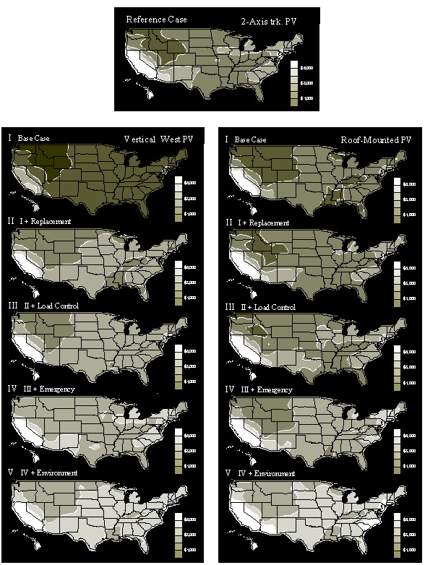
Figure 2: Geographical Distribution of PV’s breakeven turnkey cost with and without externalities for vertical and roof-mounted configurations
Base case conditions for the tilted and vertical PV configurations may be found just below the two-axis map in Fig. 2. Most of California remains above $/5000/kW for roof-mounted arrays, while the mid-Atlantic seaboard reaches $3,500. For vertical arrays, base case conditions show a BTC below $2000/kW for much of the country, with southern California reaching above $4,000.
3.2 Impact of Externalities
The maps appearing below the base case conditions in Fig.2 reflect the cumulative incorporation of each considered externality. In Figure 3, these results have been summarized for the US as a whole and three focus regions: (1) southern California (Los Angeles metro), (2) southern New York / New Jersey (New York metro) and (3) northern Washington State (Seattle metro).
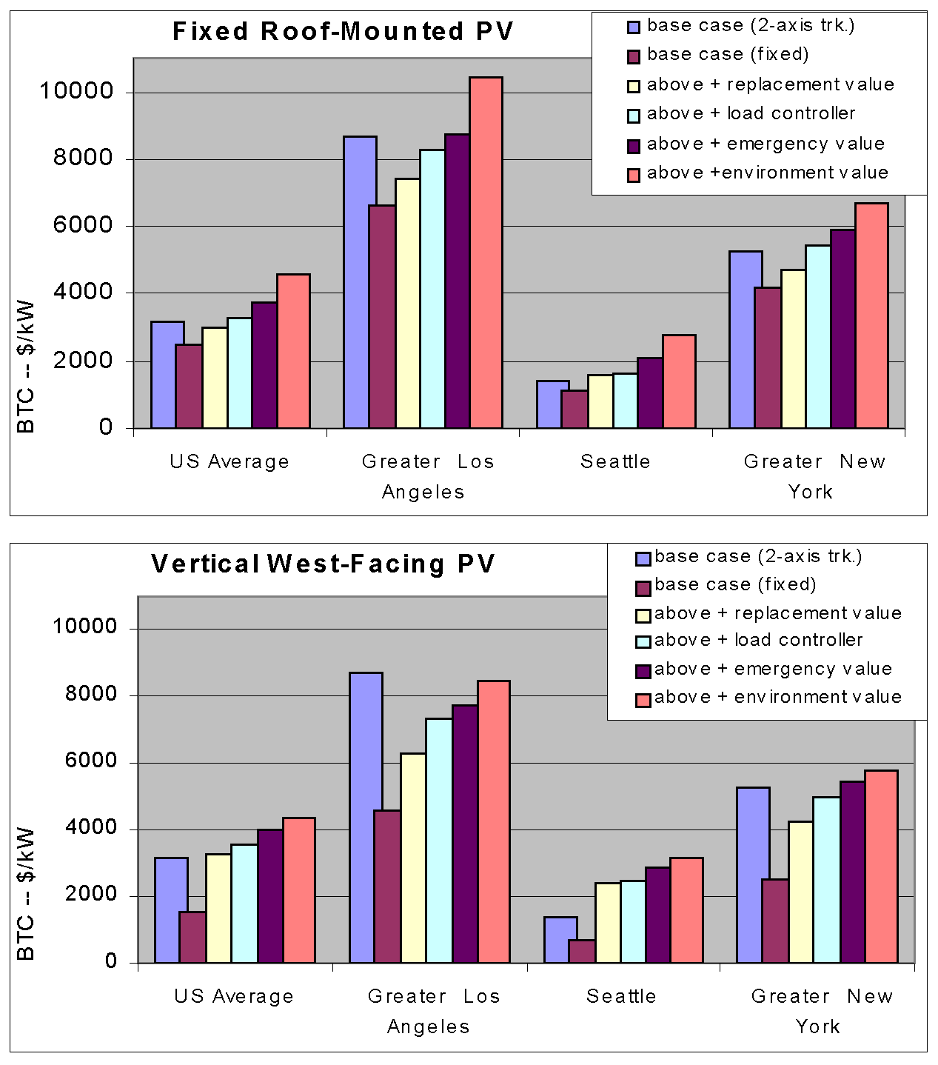
Figure 3: BTCs with and without externalities for selected US regions
Replacement Externality
This externality brings a constant value throughout the country (with a small influence on energy generation for roof-mounted arrays). As a consequence, its relative effect is most visible in regions which had the lowest BTCs. This particularly striking in the case of vertical arrays, because of the high PV replacement value. In fact, when considering only this external value element, BTCs for vertical Systems exceed those of roof mounted systems for much of the country, to the exception of regions with the highest energy and/or capacity resource/cost (California, Hawaii, Mid-Atlantic seaboard).
Load control Externality
The added value of this element depends on the value of capacity. It ranges from $100/kW or less in the northwest and to almost $500/kW in California and the eastern seaboard. Accounting for this element in addition to replacement value brings the New York metro area close to $5000/kW BTC for roof mounted systems.
Emergency
This externality also brings a constant value throughout the US, as we did not assume any geographical distribution of power outages risk. At this stage, the majority of the US land area is well above $3000/kW BTC for both roof-mounted and vertical PV configurations.
Environment
Adding this legitimate, although still intangible externality brings much of the East Coast and the southwestern US above the $5,000 BTC mark.
4. DISCUSSION
The combined effect of all externalities results in a doubling of the BTC for most US regions when compared to base case, business as usual situations. The replacement, load control, emergency and environment externalities add respectively a US average of $500, $300, $450 and $800 to the breakeven turnkey cost of commercially-sited roof-top PV installations. This brings the BTC, i.e., the maximum affordable PV cost, of both building integrated options well above the 2-axis tracking reference case.
The market impact of incorporating these externalities in business practice would be significant. In the case of roof mounted-installations, the fraction of the country with $4,000+ BTC jumps from 7% to over 60%, including 90% of the population. The above-$5,000 BTC threshold, representing BTCs clearly achievable today, would affect over a third of the US population. In California and Hawaii, the BTC would exceed $10,000/kW, while in New York this would approach $7,000.
What to do: We have shown that accounting for externalities that are either tangible (replacement, load control) or clearly justifiable (emergency, environment) could make a considerable difference in the bottom line of PV economics, hence in the size of the commercial grid-connected markets in the US.
However, a considerable challenge resides in reconciling this potential with day-to-day business reality. Given the present business-regulatory-legislative environment, there is little chance that anyone willing to invest in a very safe 9% after tax return investment (or much more in California, New York and Hawaii) could see this investment go towards the deployment of grid connected commercial PV systems, unless he/she happens to (1) own a suitable commercial site, (2) be very well educated in solar energy matters, (3) be willing to do more than one’s share for the environment, and (4) be ready to spend lots of time and energy in taking on the financial and utility/regulatory environment.
Therefore, developing the appropriate legislative, regulatory and business tools that would smoothly relate the interest of many for a safe 9%-return investment into installed PV kilowatts, in effect decoupling the investment-to-Physical PV system relationship, ought to constitute a priority to all concerned parties. Creative examples along these lines are being tested in some European countries.
5. ACKNOWLEDGEMENT
This article includes results from research projects supported by NREL (CONTRACT No. XAD-8-17671-01) and NYSERDA (No. 4694-ERTER-ER-98)
6. REFERENCE
1. Perez R., Wenger H., Herig C., (1998): Geographical Distribution of the Value of Demand-Side Commercial PV Systems in the United States. Plenary article, 2nd World PV Conference, Vienna Austria
2. Herig, C. R. Perez, and H. Wenger (1998): Commercial Buildings and PV, a Natural Match. NREL Brochure DOE/GO-1998 NREL, Golden, CO view it
3. Wenger, H., C. Herig, R. Taylor, P. Eiffert and R. Perez, (1996): Niche Markets for Grid-Connected Photovoltaics. Proc. IEEE Photovoltaic Specialists Conf., Washington, DC.
4. President's 1-million roof Program, USDOE, Washington, DC
5. Perez, R., R. Seals and C. Herig, (1997): Determination of the End-Use Effective Capacity of Photovoltaics. Proc. 14th European PV Conference, Barcelona, Spain.
6. Perez, R., R. Seals and R. Stewart, (1993): Solar Resource - Utility Load Matching Assessment. Phase One Final Report to the Natl. Renewable Energy Lab. (24 pp.). NREL/TP-411-6292, NREL, Golden, CO
7. R. Perez, R. Seals et al. (1995): Geographical Distribution of PV Effective capacity in the US. Proc. ASES-95 Annual Meeting, Minneapolis, MN. 6 pp. Brochure 2
8. R. Perez, R. Seals and C. Herig, (1996): PV Can Add Capacity to the Grid. NREL Brochure DOE/GO-10096-262, NREL, Golden, CO
9. Date base of State Incentives for renewable Energy-DSIRE, (1998). NCSC-IREC @ http://www-solar.mck.ncsu.edu/dsire.htm
10. Kiss, G. (1999): Personal Communication, Kiss & Catheart Architects, New York, NY
11. Shugar D., (1999): Personal Communication (based on Energy-10 simulations), Powerlight, Inc., Berkeley, CA
12. Development of a Solar Load Controller, NYSERDA CONTRACT No. 4694-ERTER-ER-98 NREL CONTRACT No. XAD-8-17671-01
Periodic Rept. No. 3 (reference No.12, above)
13. Perez, R., R. Seals, H. Wenger, T. Hoff and C. Herig, (1997): PV as a Long-Term Solution to Power Outages. Case Study: The Great 1996 WSCC Power Outage. Proc. ASES Annual Conference, Washington, DC. (view it now !)
14. Perez, R., (1998): Photovoltaic Availability in the Wake of the January 1998 Ice Storm. Proc. Renew 98, NESEA, Greenfield, Mass.
15. Do Kim, (1998): Personal Communication, Institute For Business & Home Safety, Boston, MA
16. Buchanan, C., P. Chernick, A. Krupnik, U. Fritsche, (1991) Environmental Costs of Electricity, Oceana Publications, Inc., New York
17. EPA’s NOx Model Rule Draft Papers, Environmental Protection Agency, Washington, DC

